Fishing Website Report

In my default browser, Google, the web page is slightly lower resolution in comparison to other web browsers. This means that when I compared it to its appearance in Microsoft Edge, I noticed an improved sharpness to the images and the text, because of its higher resolution. Other than that they looked and functioned the same.

I have 4 links in the website, although three of them all link internally to the same bookmark, the “homewrecker” ID, the fourth links externally to a gif of a fisherman. All links work correctly:

The three bookmark links scroll to the word homewrecker (the text with the ID “homewrecker”), and the external link correctly links to the fisherman gif.

HTML:
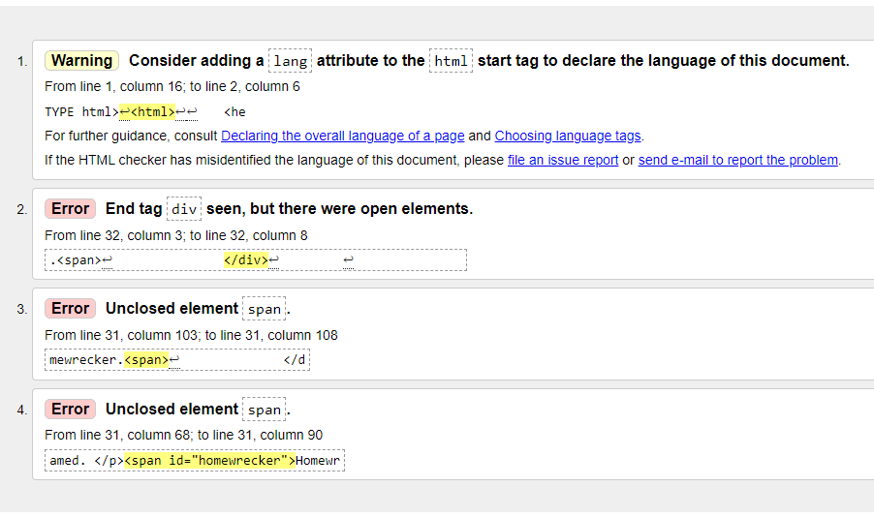
I fixed this by adding a / to the <span>, and by adding lang = ”en” to the <html> tag.

CSS:
